**Arab Academy for Science, Technology and Maritime Transport**

**Digital Electronics**

**CC341**

**Negative Edge Triggered T Flip Flop Using I2L**

**Computer Engineering Department**

**Name:** Mahmoud Saeed Osman Mohammed

**Reg Number:** 18102867

**Submission Date:** 9/6/2021

**Abstract**

This report discusses the implementation of a negative edge triggered T flip flop using the I2L logic families and all its aspects, including previous research. It starts with defining the Bipolar Junction Transistors (BJT) and stating its types and characteristics. It gives a brief summary of the RTL logic family, then discusses the I2L logic family and all its aspects including advantages, disadvantages and the implementation of an I2L inverter. In addition, the report covers what an edge triggered T flip flop is, its operation and its applications, it then covers its I2L implementation using difference methods including the use of universal NAND gate and the use of bistable multivibrators. Finally, the report covers the simulation thoroughly by analyzing the circuit and the results in great details.

**Table of Contents**

1

**Page**

I- Bipolar Junction Transistor and Logic Families

1

* Definition

1

* NPN and PNP Bipolar Junction Transistors

1

* Bipolar Junction Transistors Output Characteristics

2

* Resistor-Transistor Logic (RTL)

3

II- Integrated Injection Logic (I2L)

3

* Definition

3

* Implementation and Operation of An Inverter

3

* Advantages

4

* Disadvantages

5

III- T Flip Flop

5

* Definition

5

* Operation of An Edge Triggered T Flip Flop

5

* Applications

6

IV- Negative Edge Triggered T Flip Flop Implementation

6

* Using Logic Gates

7

* Using Bistable Multivibrators

8

* Previous Research

9

V- Simulation

9

* Circuit Analysis (555 timer)

13

* Results

14

VI- PCB Design

15

VII- Conclusion

16

VIII- Components Required and Market Study

17

IX- References

**I- Bipolar Junction Transistor and Logic Families**

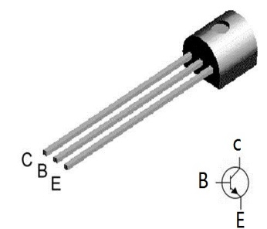**Definition**

Bipolar Junction Transistors (BJT) are semiconductors consisting of three terminals that are formed by creating two p-n junctions, these terminals are the base, the collector and the emitter as shown in Figure 1. They are considered bipolar since they use two charger carriers to operate, these charge carriers are electrons and holes. Bipolar Junction Transistors are current controlled devices, and they can be used as amplifiers through applying a small amount of current to the base and taking the amplified output at the collector without the need for any external DC sources. They are most commonly used as switches in digital circuits.

Figure 1

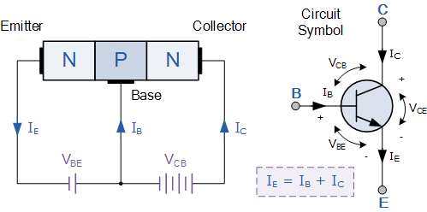**NPN and PNP Bipolar Junction Transistors**

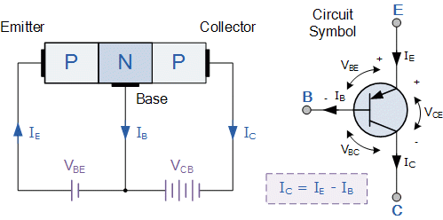Bipolar Junction Transistors are divides into two main types which are NPN or PNP, this depends on the doping of their terminals of the transistor. NPN Bipolar Junction Transistors are the most common and they consist of two N-type semiconductors, these are the emitter and collector terminals, and one P-type semiconductor in the middle which is the base terminal. PNP Bipolar Junction Transistors are less common that NPN and are typically used as current sources, they consist of two P-type semiconductors, these are the emitter and collector terminals, and one N-type semiconductor in the middle which is the base terminal. The main difference between both types of BJTs is the direction of currents and voltages as shown in Figure 2.

Figure 2

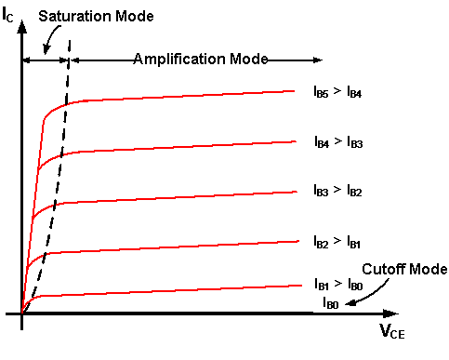**Bipolar Junction Transistors Output Characteristics**

The output characteristics curve of Bipolar Junction Transistors is important since it shows relation between Ic and Vce given a range of base currents which shows the three different modes of a BJT, these modes are Active (Amplification), Saturation and Cutoff. BJTs operate in active regions when they act as amplifiers and the operate in saturation and cutoff regions when they act as a digital switch, these different regions are shown in Figure 3.

Figure 3

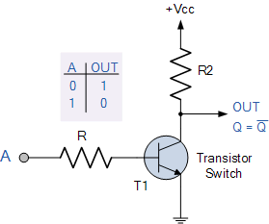**Resistor-Transistor Logic (RTL)**

Resistor transistor logic (RTL) was the most common logic family since it was used in making AND, OR, NAND, NOR, XOR and NOT gates and it replaced diode logic since it was only capable of making AND and OR gates. An RTL inverter can be made easily using basic components like resistors and NPN BJT transistors, the input is connected to the base while the output is taken at the collector and the collector is connected to Vcc. As shown in Figure 4, when the input A is high, the transistor is switched ON and the output is LOW since it passes to ground, but when the input A is low, the transistor is switched OFF and the output is HIGH since it passes to the Vcc. RTL was replaced with newer and better technologies such as I2L and TTL since they had superior switching times and a higher packing density.

Figure 4

**II- Integrated Injection Logic**

**Definition**

Integrated injection logic (I2L) or merged transistor logic (MTL) is a logic family that was developed in 1971 which uses two different types of bipolar junction transistors to form gate ICs, it commonly uses multiple collector BJT NPN transistors along with BJT PNP transistors acting as current sources. It was mainly developed due to the need for circuits with high packing density with extremely fast switching times. I2L completely replaced RTL since it had superior packing density and was favored over TTL in some cases since TTL did not have a lower packing density. I2L can be used to make multiple logic gates such as AND, OR, NAND, NOR and NOT gates, it can also be using in the implementation of multivibrators.

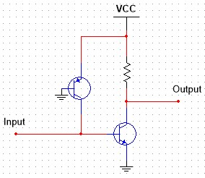**Implementation and Operation of An Inverter**

An I2L inverter is very similar to an RTL inverter, the only difference is that every resistor is replaced with a PNP BJT acting as a current source as show in Figure 5. When the Input is HIGH, the NPN transistor is ON, so the output is passed to ground, so it is LOW, when the input is LOW, the NPN transistor is OFF, the output is passed to the Vcc so it is HIGH. The operation is identical with the difference being that I2L requires less voltage to operate and provides a smaller footprint over RTL.

Figure 5

**Advantages**

Integrated Injection logic has serval advantages over other logic families. It replaces resistors with transistors which in turn increases the packing density of the technology since the size of transistors is far smaller than that of resistors, this eliminated the use of RTL. It has quick switching times combined with high packing density which enables it to be easily used in very large-scale integration (VLSI) circuits. I2L uses bipolar junction transistors which possess a high speed of operation and enables I2L gates to be easily integrated with other logic families. In addition, Integrated injection logic requires very low voltage to operate and has lower power dissipation than TTL and RTL which ends up saving cost.

**Disadvantages**

The drawbacks of I2L are not as prominent as its advantages. One of these disadvantages is that it has a very low voltage swing which is approximately equal to 0.6v, this forces the use of very low operation voltages which eliminates the use of this technology in circuits where higher voltages are needed. An external resistance is needed in I2L circuits in order to limit the current going into the PNP transistors, resistors are also used as pull-up or pull-down resistors as shown in Figure 5. The introduction of the CMOS logic family completely eliminated the use of I2L and made it an obsolete technology today, CMOS had a lower packing density than I2L and CMOS gates drew less overall power than I2L gates since I2L gates do not stop drawing power when they are not switching.

**II- T Flip Flop**

**Definition**

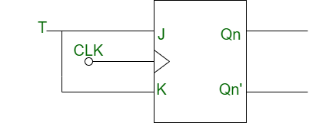A flip flop is a digital bistable component that has two stable states and is fundamental component that is needed for building computers and electronic systems, it is used mainly in the storage of data in form of binary bits. A flip flop can take either one or more inputs which are enabled by the transition of the CLOCK input so flip flops are said to be edge triggered, a flip flop changes state depending on the previous state and the input at each edge of the clock. Edge triggered flip flops have four kinds JK, D, SR and T flip flops. T flip flops implement the toggle state, they are a modified version of the JK flip flop with only one input T along with CLOCK input as shown in Figure 6.

Figure 6

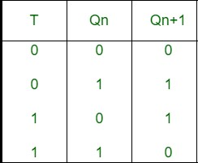**Operation of An Edge Triggered T Flip Flop**

An edge triggered T flip flop has one input T and the CLOCK input, it has two outputs Q and its compliment. At each positive or negative edge of the clock, the next state output changes or remains the same depending on the input T, if T is HIGH then the next state output changes to the compliment of the pervious stage output, however the next stage output remains the same as that of the pervious state output if the input T is LOW. Figure 7 shows the excitation table of the T flip flop.

Figure 7

**Applications**

T flip flops are considered to be an essential building block in computers. They are used mainly in storage registers which are a major part of any computer architecture that exist today, since they provide access to data at tremendous speed ensuring quick and efficient operation. T flip flops are also used to implement frequency divider circuits which are used to divide the frequency of periodic wave forms. Moreover, counters are manufactured using T flip flops. Counters are a very important element in digital electronics, they can be utilized to measure time, preform counting operations in certain patterns, perform athematic operations like addition and most importantly they are used in computer architectures to increment memory addresses in order to perform certain instructions.

**IV- Negative Edge Triggered T Flip Flop Implementation**

**Using Logic Gates**

A negative edge triggered T flip flop can be implemented using the universal logic gate NAND. As shown in Figure 8, input T and the CLOCK input are connected to the first and second NAND gate, output Q is connected to the first NAND gate and Q compliment is connected to the second NAND gate. The output of the first NAND gate goes to the third NAND and the output of the second NAND gate goes to the fourth NAND. The output of the third NAND is Q and is connected to the Fourth NAND input, and the output of the fourth NAND is Q compliment and is connected to the third NAND input. One approach to implement the edge triggered T flip flop is by using I2L, since I2L can be used to make multiple input NAND gates as shown in Figure 9, however this approach is not practical because it requires approximately 50 BJT transistors to make the four NAND gates, this leaves a huge room for error. Another approach is to make NAND gates using a combination of both DL and I2L logic families as displayed in Figure 10, an AND gate can be made using diode logic then the output is passed to an I2L inverter.

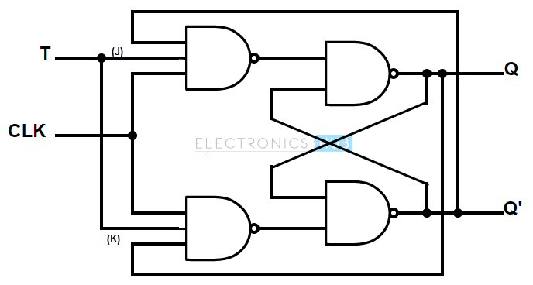

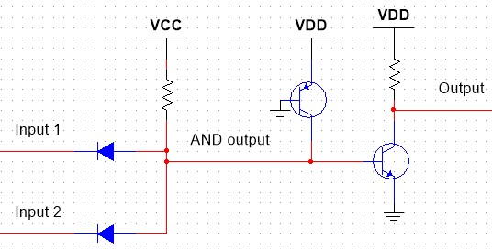

Figure 10

Figure 9

Figure 8

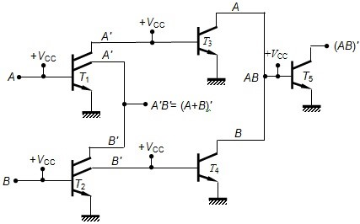

**Using Bistable Multivibrators**

Multivibrators are digital components that operate continuously between two states which are HIGH and LOW, they can produce non-sinusoidal waveforms, such as square, rectangle and triangular waves. They operate in a sequential manner and oscillate between the HIGH and LOW state. They have three types, Astable, Monostable and Bistable, these types differ in their applications and the number of stable states they have. Bistable multivibrators have two stable states and are generally used as flip flops, they operate only in one continuous state since they lack a timing circuit. They require a clock which can be in the form of a square wave or pulse generator in order to switch between states. A T flip flop can be made using a sequential switching bistable multivibrator with a trigger input that can be a pulse generator as displayed in Figure 11, it changes state at the negative edge of the pulse making it a negative edge triggered T flip flop, this flip flop can be simply implemented using I2L by simply switching each resistor in the circuit with a PNP BJT transistor acting as a current source.

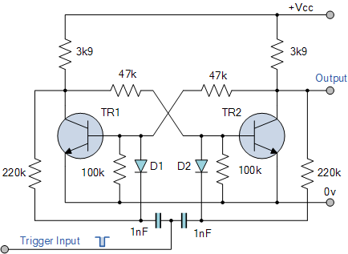

Figure 11

**Previous Research**

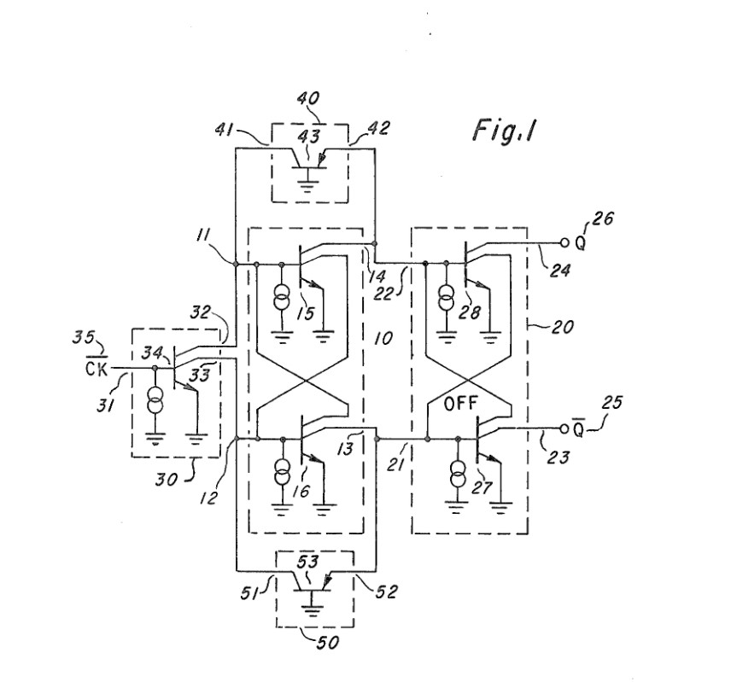One of the previous approaches of implementing an edge triggered T flip flop is a patent assigned by Texas Instruments Inc and invented by Walter H. Banzhaf in 1977. A triggerable flip flop was made using I2L, it was comprised of a master stage and slave stage which were controlled by a CLOCK input as shown in Figure 12, the flip flop switches states when the CLOCK input changes from HIGH to LOW making it a negative edge triggered T flip flop. The master stage has two transistors representing both Q and Q compliment , it controls which state does the slave stage output .The master stage is selectively turned ON or OFF by the CLOCK input, when the CLOCK input is HIGH, both transistors of the master stage are turned OFF, when the CLOCK input is LOW one of the transistors of the master stage representing one of the states is turned on then the slave stage responds to that state and outputs it. Figure 13 represents the output waveform of the T flip flop, 2nd and 3rd transistors are the master stage transistors, 4th transistor represents the output Q, and the 5th transistor represents the output Q compliment. This approach is rather complicated and hard to implement due to use of multi-collector NPN BJT transistors which are not readily available.

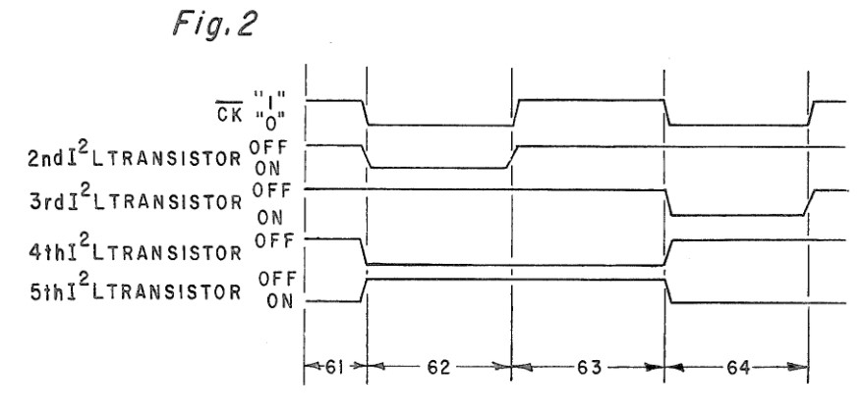

Figure 13

Figure 12

**V- Simulation**

**Circuit Analysis**

The bistable multivibrator approach was the most feasible since it was the easiest to understand and all the components it needs are readily available to purchase. A collector coupled fixed bias bistable multivibrator can be used to implement the T flip flop, this type of bistable multivibrator differs from the other types since it has two voltage supplies, the second one is responsible for sending a trigger to turn the transistors ON or OFF. Figure 14 represents the final circuit of a negative edge triggered T flip flop using I2L, as stated, every resistor in Figure 11 was switched with a PNP BJT transistor which guides the current in the circuit, a 2.2k Ohm resistor was added at the Vcc along with two 330 Ohm resistors added at the base of PNP transistors Q3 and Q4, these resistors we added in order to limit the current going into the transistors to ensure correct operation without any of the transistors failing. The input of circuit is a 5v pulse generator which acts as the CLOCK input, the output of the T flip flop is Q at X2 and not Q at X1.

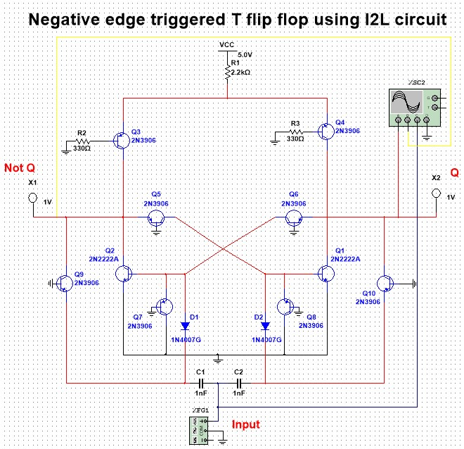

Figure 14

The input sends pulses to C1 and C2 commutating capacitors that ensure that the transistor can turn OFF by supplying negative voltage, D1 and D2 are biased diodes acting as a steering circuit, they ensure that the base of Q1 and Q2 NPN BJT transistors receive that negative voltage in order to turn OFF. The switching between the two stable states occurs when the CLOCK input is at its falling edge, so the negative edge of the clock is considered the trigger. At each negative edge, the ON transistor will turn OFF due to the effect of the commutating capacitors, and the OFF transistor will turn ON allowing the circuit to switch between the two states.

Figure 15 shows the first stable state of the flip flop. Q1 transistor is turned OFF and Q2 transistor is turned ON, this causes X2 LED to turn ON stating that the Q output is HIGH, and the X1 LED to turn OFF stating that the output Not Q is LOW.

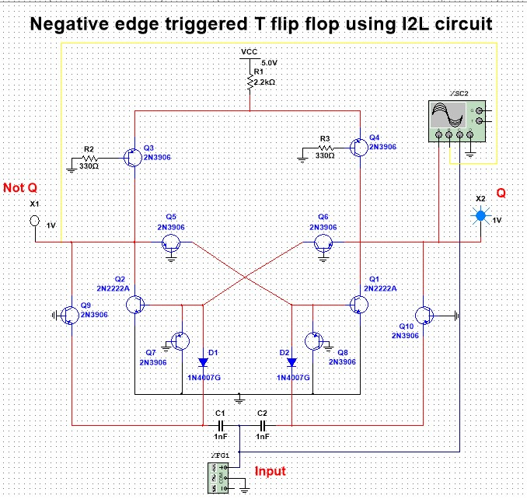

Figure 15

Figure 16 represents the second stable state of the flip flop. Q2 transistor is turned OFF and Q1 transistor is turned ON, this causes X1 LED to turn ON stating that the Not Q output is HIGH, and the X2 LED to turn OFF stating that the output Q is LOW.

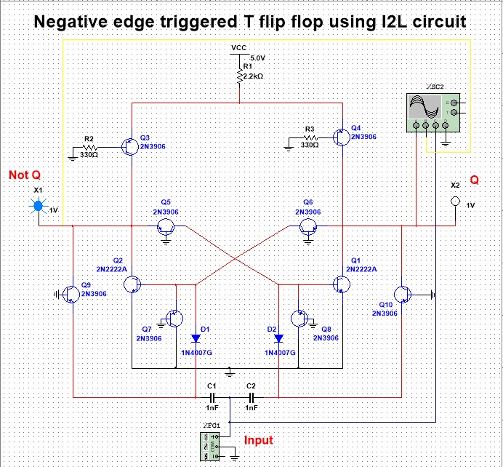

Figure 16

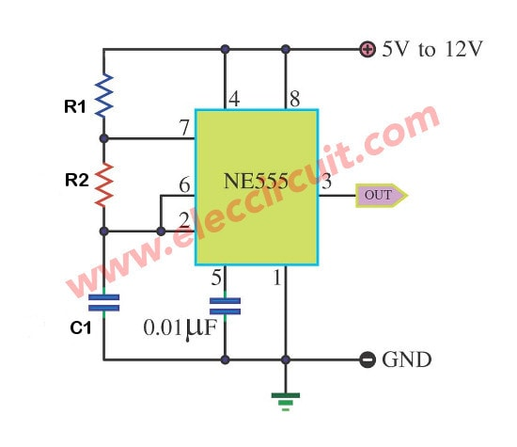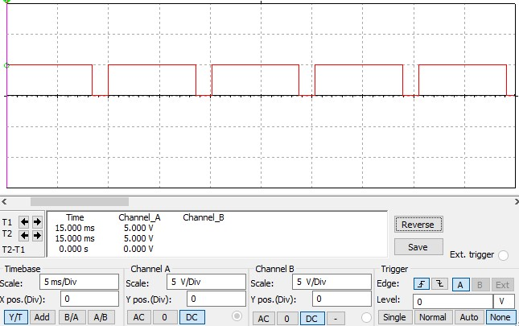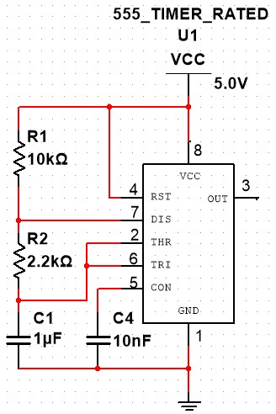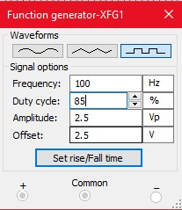Since I do not have access to a pulse generator, I decided to implement a pulse generator circuit using the 555 timer and use it as my input. My pulse generator outputs 5v at a frequency of 100 HZ and a duty cycle of 85% as displayed in Figure 17. A 555 timer can be an astable multivibrator that generates a pulse waveform, that achieved by connecting two resistances, a capacitor and a supply voltage to the correct pins, Figure 18 represents the pulse generator 555 timer circuit. In order to achieve the correct frequency and duty cycle, the values of R1,R2 and C1 have to be tweaked according to some formulars, these formulas are, Frequency (f)= 1.44/(R1+2R2)C1, Cycle Time (Tc) =1/f, Pulse Width (pw) =0.693(R1+R2)C1 and Duty Cycle = (pw/Tc)x100, using these formulas a frequency of 100 HZ and a Duty Cycle of 84.55% (approximately equal to 85%) were achieved by setting R1= 10k Ohm, R2= 2.2k Ohm, C1= 1u F. The final pulse generator circuit is shown in Figure 19 and the output waveform is displayed in Figure 20.

Figure 18

Figure 20

Figure 19

Figure 17

**Results**

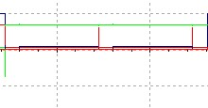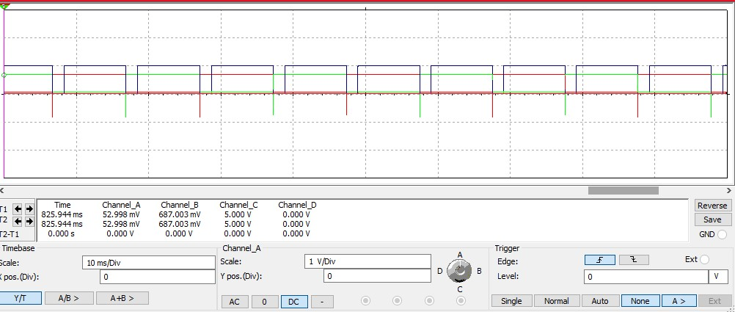Figure 21 displays the output waveform of the circuit, the BLUE pulse is the input from the pulse generator into the circuit, the RED pulse represents the output Q, and the GREEN pulse represents the output Not Q. As predicted, the output Q changes state from HIGH to LOW and vice versa at each negative edge of the input, Not Q compliments Q, this is the expected output waveform of a negative edge triggered T flip flop. There are some voltage spikes at each negative edge which might be the result of the capacitors discharging, or the transistors characteristics or problem with the simulation. There are also some input pulses, shown in Figure 22, that are below the 5v peak, this might be caused by capacitors charging in the 555-timer circuit or because the 555 timer is not ideal, the state does not change during these pulses since there is no negative edge to trigger the circuit. To measure the output waveform, an oscilloscope is required which I do not have access to, but I might be able to make one by using an Arduino.

Figure 21

Figure 20

**VI- PCB Design**

Implementing the circuit on a Printed Circuit Board was rather easy. The components needed to be changed to available packages in order to be transferred from Multisim 14.2 to Ultiboard 14.2. The PCB ended up being a double layer PCB, since some connections were crossing over each other, in order to print the PCB here in Alexandria it had to be a single layer PCB. The fix to that problem was to use jumper cables to replace traces on the other layer of the PCB, thus making it a single layer. Traces were added for VCC, Ground, Q and Not Q. Figure 22 shows the final PCB design and Figure 23 and 24 represents the 3D view of top and bottom copper layers respectively.

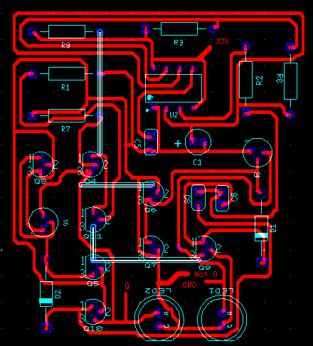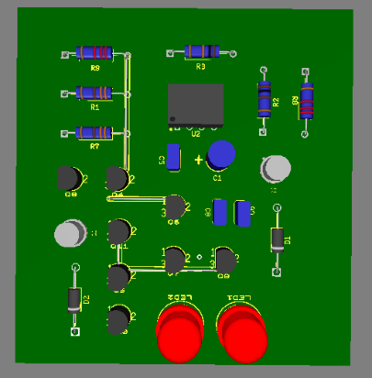

Figure 23

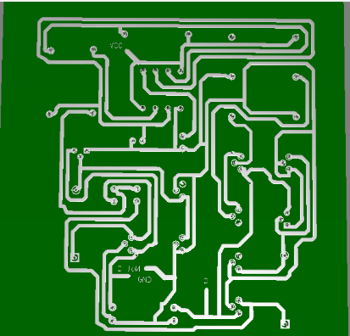

Figure 22

Figure 24

**VII- Conclusion**

Although the I2L logic family was ahead of its time when it came out, it became obsolete quickly, due to the invention of the CMOS technology which was simpler and outperformed it in every aspect including the packing density and quick switching times. However, I2L was one of the technologies which led to the quick development of digital electronics. Implementing an edge triggered T flip using I2L proved to be a challenging task due to the lack of resources and references about the technology and due to the many simulation errors, that occurred, the project required a lot of experimentation with the design, it also required me to build a pulse generator circuit in order to supply the CLOCK input. Leaving all that aside, I was able to implement the T flip flop with the expected output waveform while using components that are easily acquired.

**VIII- Components Required and Market Study**

|  |  |  |
| --- | --- | --- |
| **Component** | **Quantity** | **Price (EGP)** |
| **2N2222 NPN BJT Transistor** | **2** | **1** |
| **2N3906 PNP BJT Transistor** | **8** | **4** |
| **2.2K Ohm Resistor** | **2** | **0.2** |
| **330 Ohm Resistor** | **2** | **0.2** |
| **100 Ohm Resistor** | **1** | **0.1** |
| **10k Ohm Resistor** | **1** | **0.1** |
| **1nf Ceramic Capacitor** | **2** | **0.5** |
| **10nf Ceramic Capacitor** | **1** | **0.25** |
| **1uf Electrolytic Capacitor** | **1** | **0.5** |
| **LM555 Timer** | **1** | **2** |
| **Breadboard** | **1** | **30** |
| **Jumper Wire Kit** | **1** | **35** |
| **40 Pin Male-Male Wires** | **1** | **40** |
| **L7805 5v Regulator** | **1** | **2** |
| **9v Battery** | **1** | **20** |
| **Arduino Uno R3** | **1** | **130** |
| **LED** | **2** | **0.5** |
| **1N4007 Diode** | **2** | **0.5** |

**Total Price Required: 270 EGP**

**IX- References**

1. Bipolar Transistor Tutorial, The BJT Transistor. Basic Electronics Tutorials. (2021, March 19). https://www.electronics-tutorials.ws/transistor/tran_1.html.
2. Electrical4U. (2020, September 13). Bipolar Junction Transistor (BJT): What is it & How Does it Work? Electrical4U. https://www.electrical4u.com/bipolar-junction-transistor-or-bjt-n-p-n-or-p-n-p-transistor/.
3. Oscar, Oscar, olivier 8th April 2015 at 9:32 am, 21312 19th November 2014 at 8:40 pm, & Lutz v. Wangenheim 2nd April 2016 at 5:30 pm. (2015, June 18). How to use BJT Bipolar Junction Transistor - Beginner's Tutorial. Oscar Liang. https://oscarliang.com/bjt-bipolar-junction-transistor-beginner-tutorial/.
4. NPN Transistor Tutorial - The Bipolar NPN Transistor. Basic Electronics Tutorials. (2018, October 1). https://www.electronics-tutorials.ws/transistor/tran_2.html.
5. PNP Transistor Tutorial - The Bipolar PNP Transistor. Basic Electronics Tutorials. (2018, February 24). https://www.electronics-tutorials.ws/transistor/tran_3.html.
6. How can one connect a transistor to act as a gate, e.g inverter to real circuit? Quora. (n.d.). https://www.quora.com/How-can-one-connect-a-transistor-to-act-as-a-gate-e-g-inverter-to-real-circuit.
7. Hrishikesan, S. (2018, October 7). Integrated Injection Logic Operation. Electronics and Communication Study Materials. https://www.electronicsandcommunications.com/2018/10/integrated-injection-logic-operation.html.
8. Wikimedia Foundation. (2021, February 21). Integrated injection logic. Wikipedia. https://en.wikipedia.org/wiki/Integrated_injection_logic.
9. Toggle Flip-flop. Basic Electronics Tutorials. (2020, December 9). https://www.electronics-tutorials.ws/sequential/toggle-flip-flop.html.
10. Digital Electronics: What is a Flip-Flop? dummies. (n.d.). https://www.dummies.com/programming/electronics/diy-projects/digital-electronics-what-is-a-flip-flop/.
11. Saurabh. (2020, January 20). Flip Flop: Truth Table & Various Types: Basics for Beginners. Electronics For You. https://www.electronicsforu.com/technology-trends/learn-electronics/flip-flop-rs-jk-t-d.
12. Conversion of J-K Flip-Flop into T Flip-Flop. GeeksforGeeks. (2020, April 22). https://www.geeksforgeeks.org/conversion-of-j-k-flip-flop-into-t-flip-flop/.
13. Laxmi AshritLaxmi is a B.E (Electronics & Communication) and has work experience in RelQ Software as Test Engineer and HP as Technical support executive. She is an author. (2019, September 17). T FLIP FLOP - Construction/ Design, Working Principle and Applications. electricalfundablog.com. https://electricalfundablog.com/t-flip-flop-construction-design-working/.
14. Administrator. (2017, December 24). Introduction to Counters. Electronics Hub. https://www.electronicshub.org/introduction-to-counters/#:~:text=Counters%20are%20used%20not%20only,circuit%20by%20the%20flip%20flops.
15. Bistable Multivibrator or Flip-flop Multivibrator. Basic Electronics Tutorials. (2018, March 4). https://www.electronics-tutorials.ws/waveforms/bistable.html.
16. What is a Multivibrator? Definition, Circuit Configuration, Types and Applications of Multivibrators. Electronics Coach. (2018, December 1). https://electronicscoach.com/multivibrator.html.
17. Multivibrators including Monostable, Astable and Bistable. Basic Electronics Tutorials. (2020, September 18). https://www.electronics-tutorials.ws/sequential/seq_3.html.
18. Google. (n.d.). US4197470A - Triggerable flip-flop (Previous Research). Google Patents. https://patents.google.com/patent/US4197470A/en.
19. Apichet Garaipoom I love the electronic circuits. I will collect a lot of circuit electronics to teach my son and are useful for everyone., Garaipoom, A., & I love the electronic circuits. I will collect a lot of circuit electronics to teach my son and are useful for everyone. (2020, September 5). Simple 555 Pulse Generator circuits: Tested. ElecCircuit.com. https://www.eleccircuit.com/simple-555-pulse-generator-circuit/.
20. 555 Oscillator Tutorial - The Astable Multivibrator. Basic Electronics Tutorials. (2021, April 14). https://www.electronics-tutorials.ws/waveforms/555_oscillator.html.
21. ELECTRA GROUP is the leading Electronics Components Company since 2007 which sells all Electronic Components, Development Boards, Industrial spare parts and Tools for Engineers and anyone interested in Electronics. Electra. (2021, April 13). https://electra.store/.